# Calculate the RSI with Python and talib

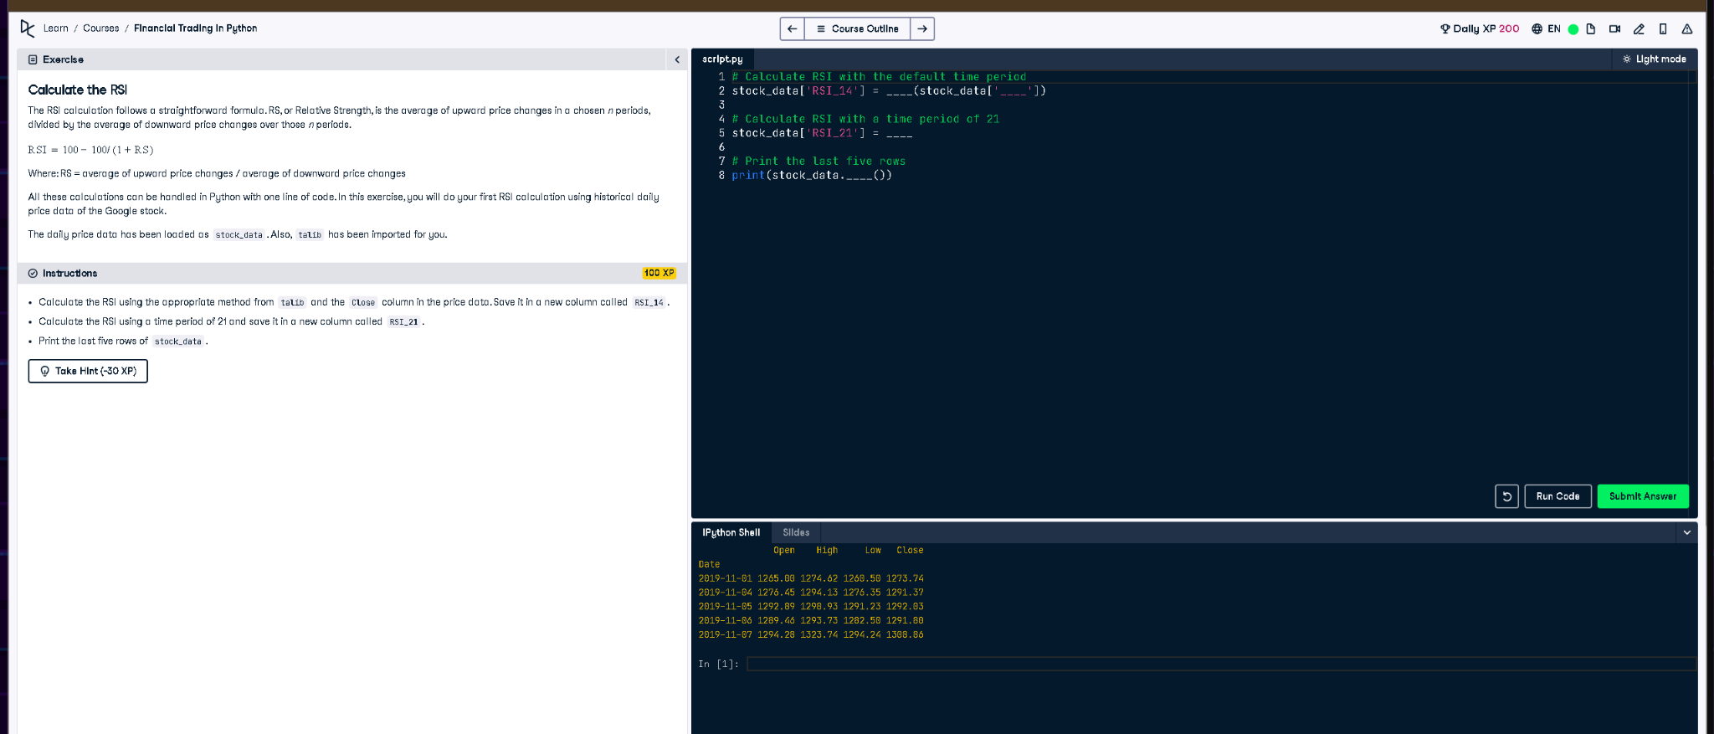

## Full Python Code

# Calculate RSI with the default time period (14)  
stock_data['RSI_14'] = talib.RSI(stock_data['Close'])  
  
# Calculate RSI with a time period of 21  
stock_data['RSI_21'] = talib.RSI(stock_data['Close'], timeperiod=21)  
  
# Print the last five rows of the dataset  
print(stock_data.tail())

## Simple Explanation (50 Words)

We calculate RSI (Relative Strength Index) using the talib library, which helps identify overbought/oversold conditions. RSI_14 uses a 14-day period by default, and RSI_21 uses a 21-day period. We save these as new columns in the stock data and print the last 5 rows to see the result.